App & Web Servers
Task 1: Install Nginx and Run on Port 81
Step 1: Install Nginx
sudo dnf install nginx -y
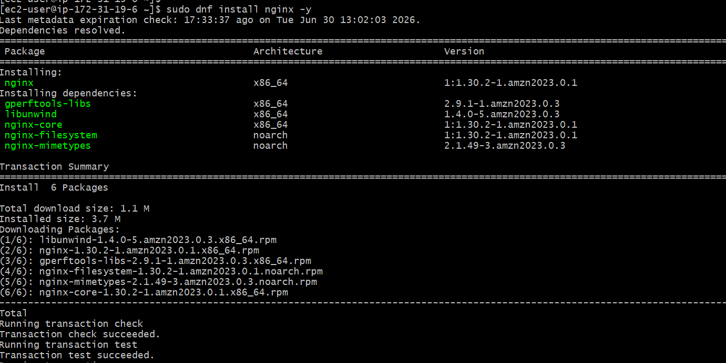

Step 2: Change Port to 81
Edit configuration:
sudo vi /etc/nginx/nginx.conf
Find & listen 80;Change it to listen 81; Save and exit.
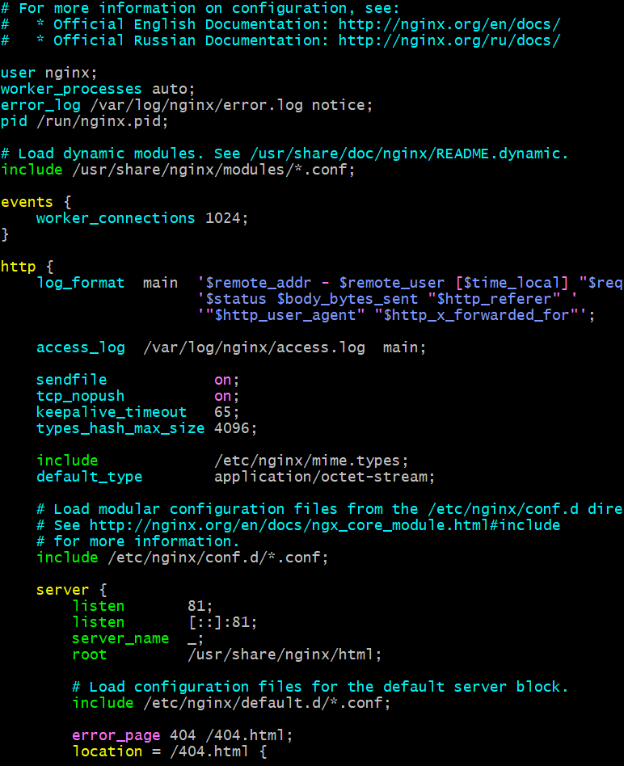

Task2: Deploy Sample index.html file on nginx
sudo vi /usr/share/nginx/html/index.html
Paste
<html>
<head>
<title>Nginx</title>
</head>
<body>
<h1>Welcome to Nginx Server</h1>
<h2>Running on Port 81</h2>
</body>
</html>
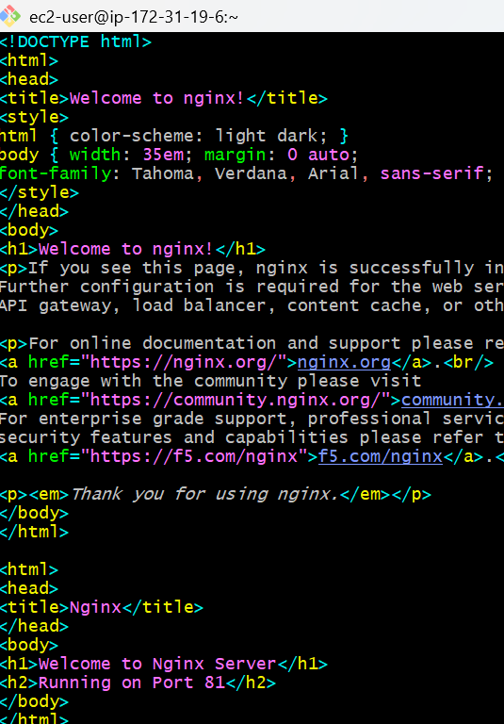

Step 4: Start Nginx
sudo systemctl enable nginx
sudo systemctl start nginx
sudo systemctl status nginx
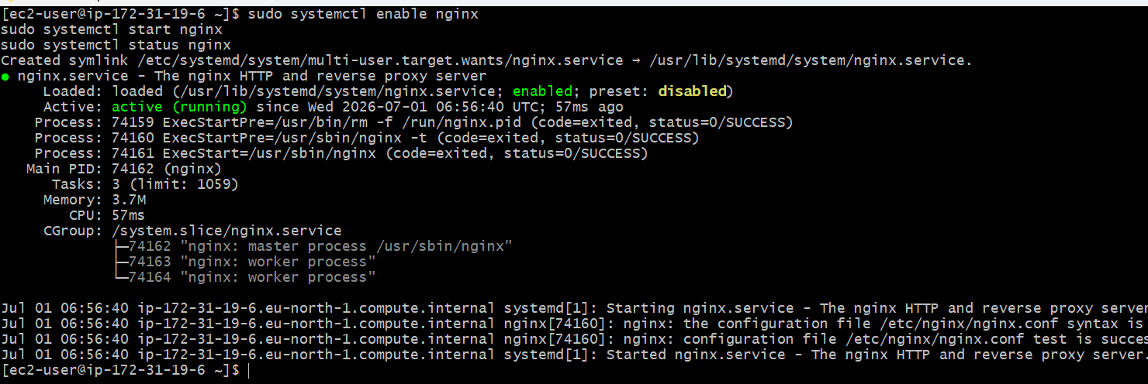
Test
curl http://localhost:81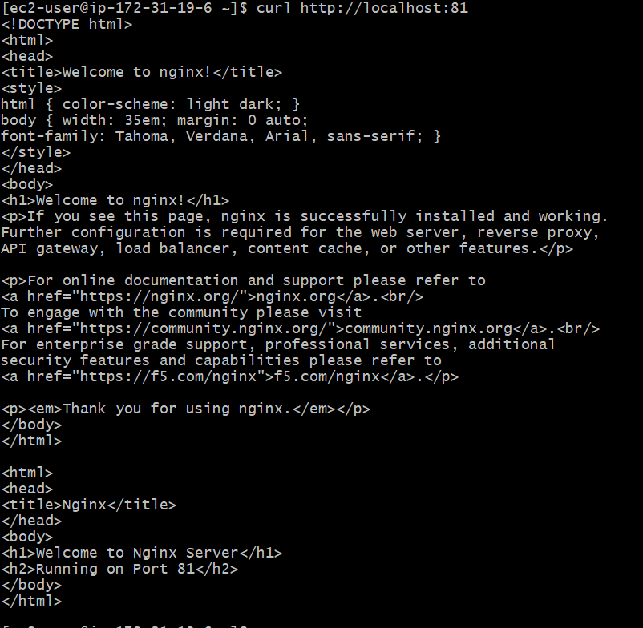

or
http://Public-IP:81
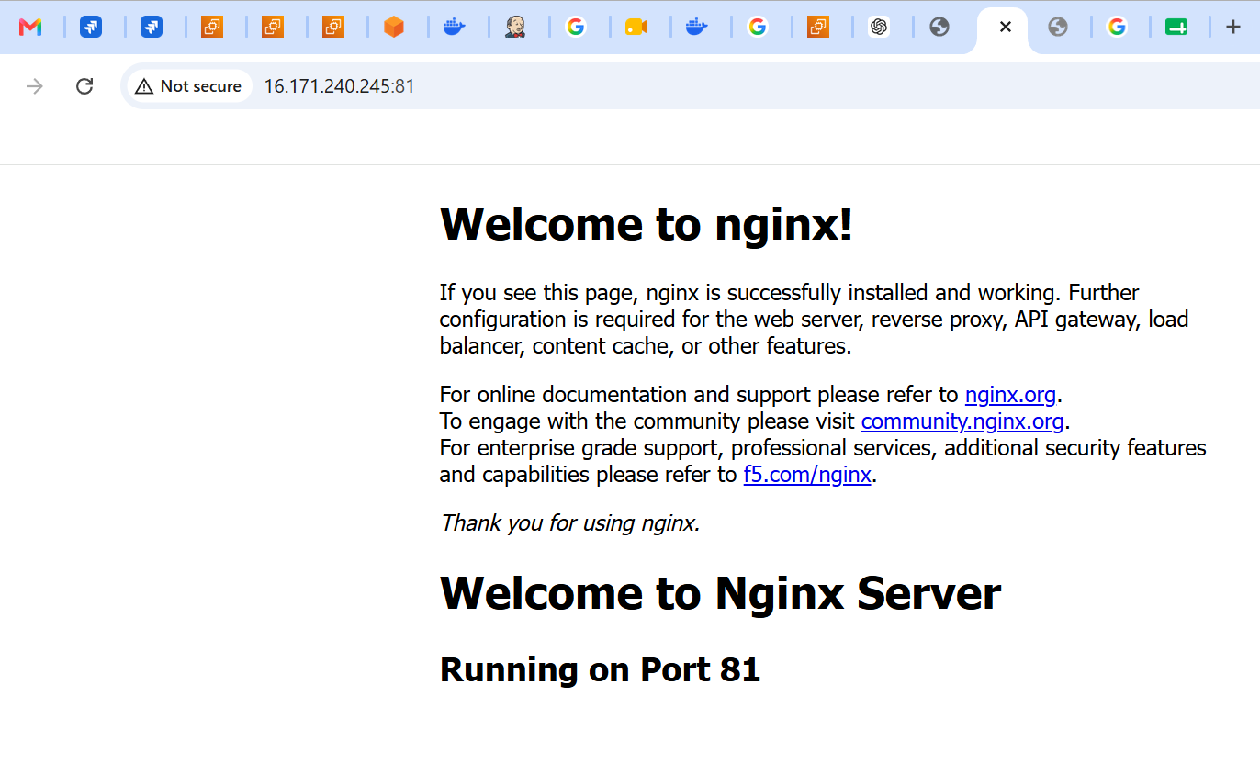

Task 3: Install Apache and Run on Port 82
Install Apache
sudo dnf install httpd -y
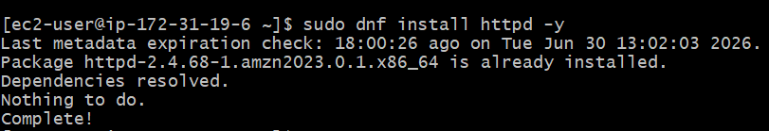

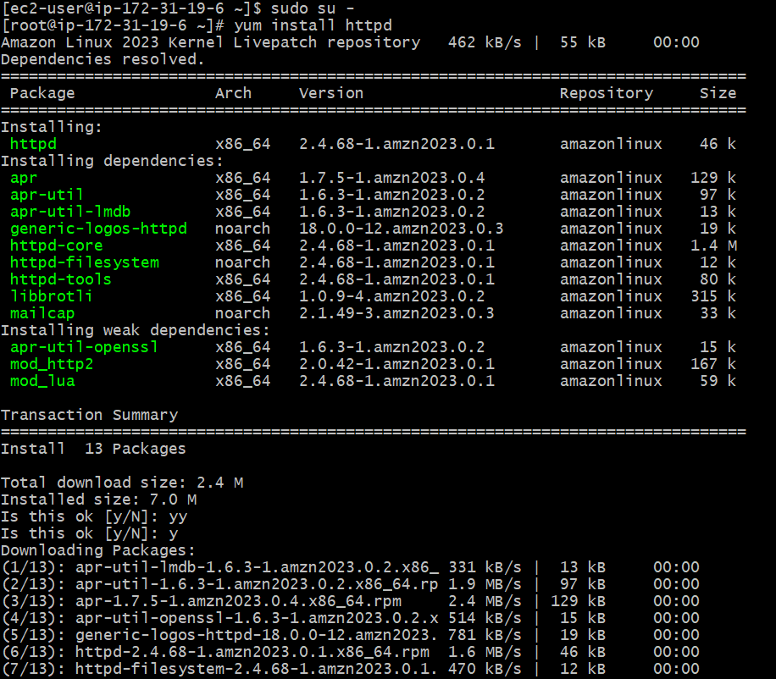
Change Port
Edit
sudo vi /etc/httpd/conf/httpd.conf
Change Listen 80 to Listen 82
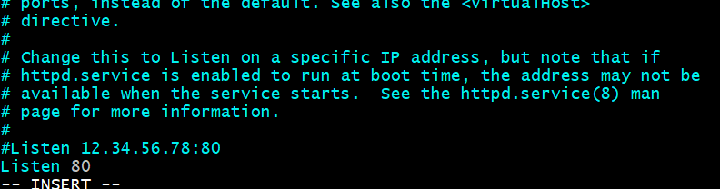
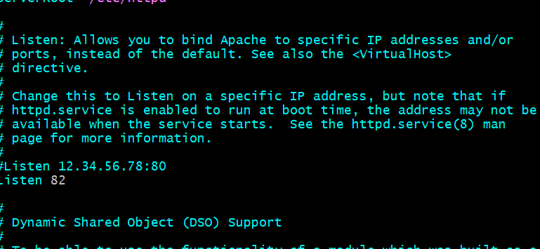
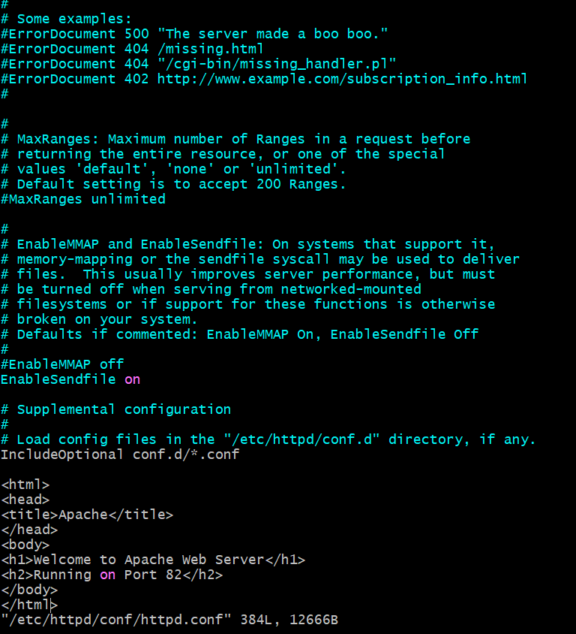
Task4 :Deploy a Sample index.html file on apache
sudo vi /var/www/html/index. html
Paste
<html>
<head>
<title>Apache</title>
</head>
<body>
<center>
<h1>Apache Web Server</h1>
<h2>Running on Port 82</h2>
</center>
</body>
</html>
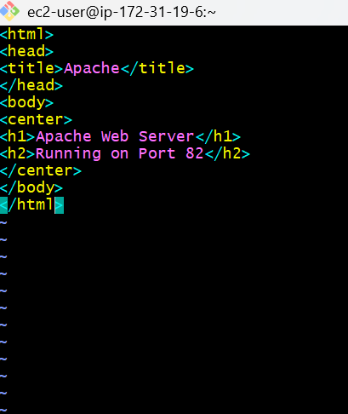
Start Apache
sudo systemctl enable httpd
sudo systemctl start httpd
sudo systemctl status httpd
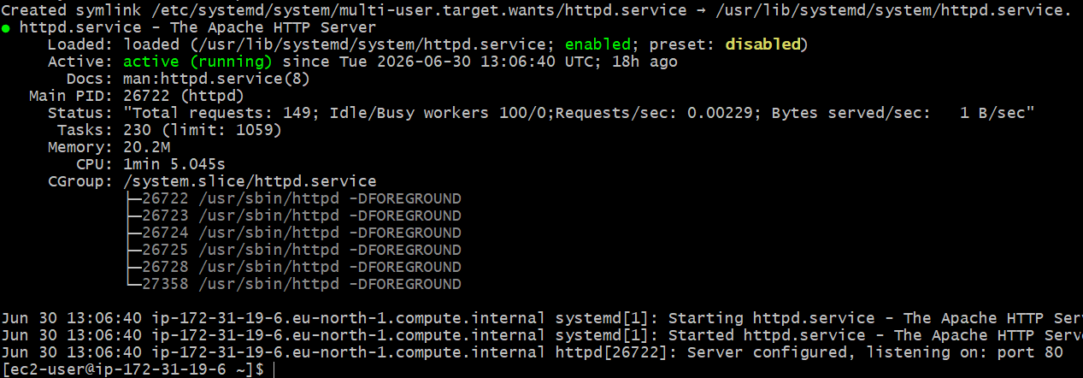
Test
curl http://localhost:82
or
http://Public-IP:82
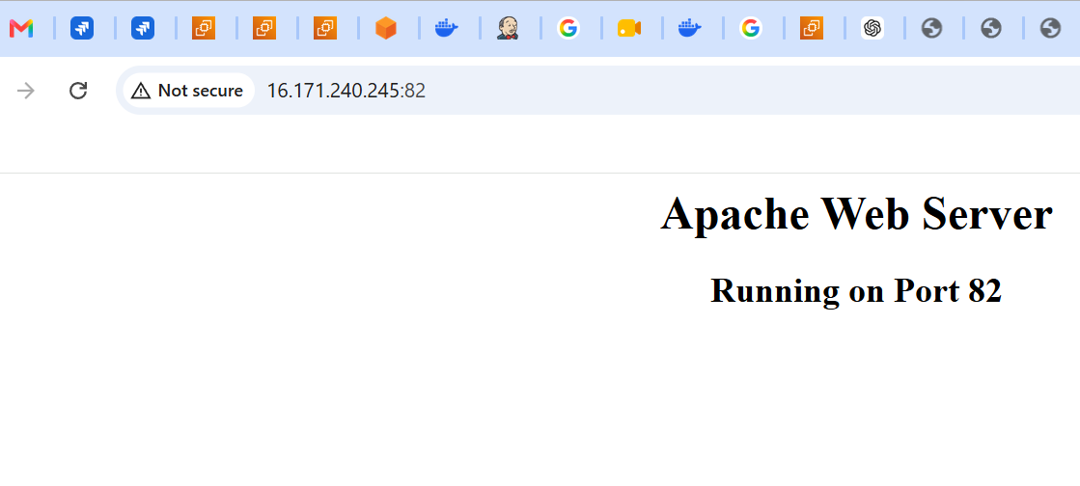
Task 5: Install Apache Tomcat on Port 8082
Install Java
sudo dnf install java-17-amazon-corretto -y
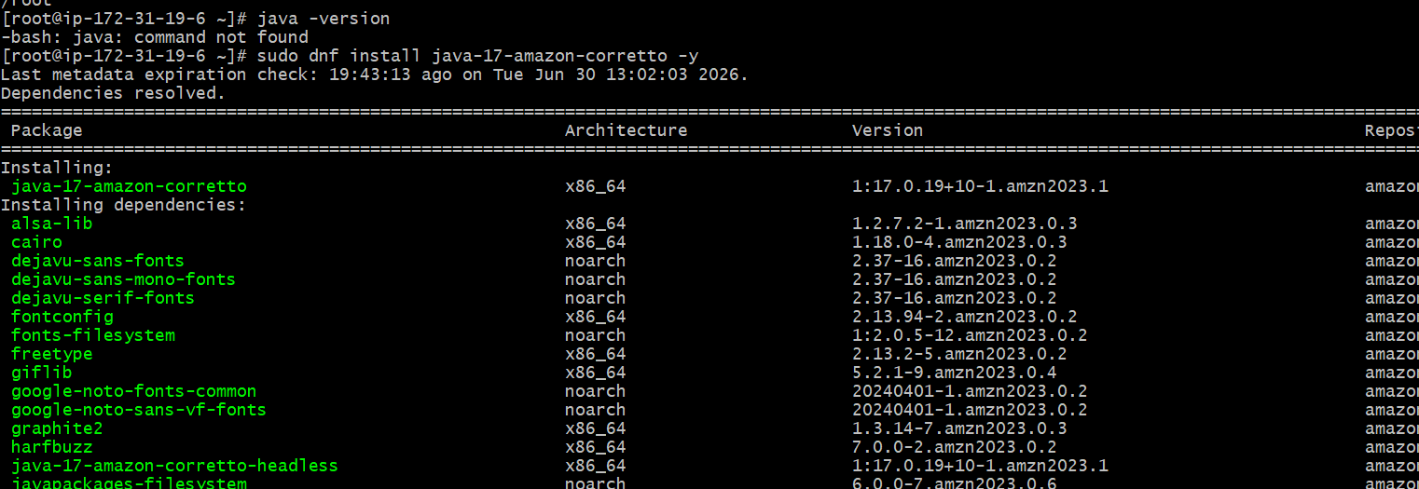
Verify
java -version
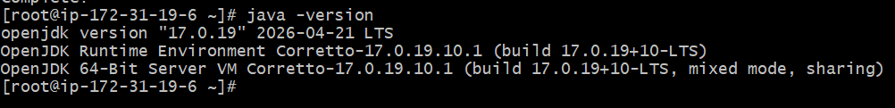
Download Tomcat
cd /opt
sudo wget https://archive.apache.org/dist/tomcat/tomcat-10/v10.1.44/bin/apache-tomcat-10.1.44.tar.gz
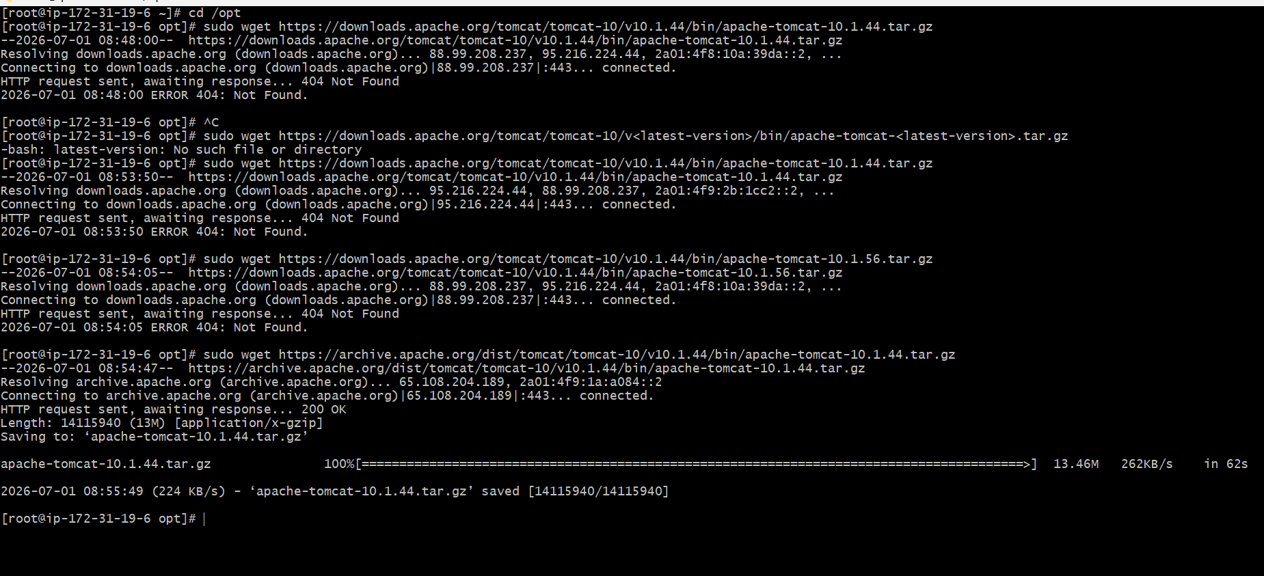
Extract - sudo tar -xvf apache-tomcat-10.1.44.tar.gz
Rename - sudo mv apache-tomcat-10.1.44 tomcat
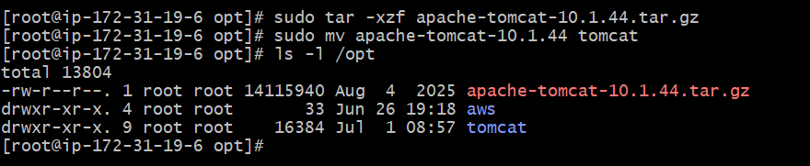
Change Port to 8082
Edit
sudo vi /opt/tomcat/conf/server.xml
Find
<Connector port="8080"
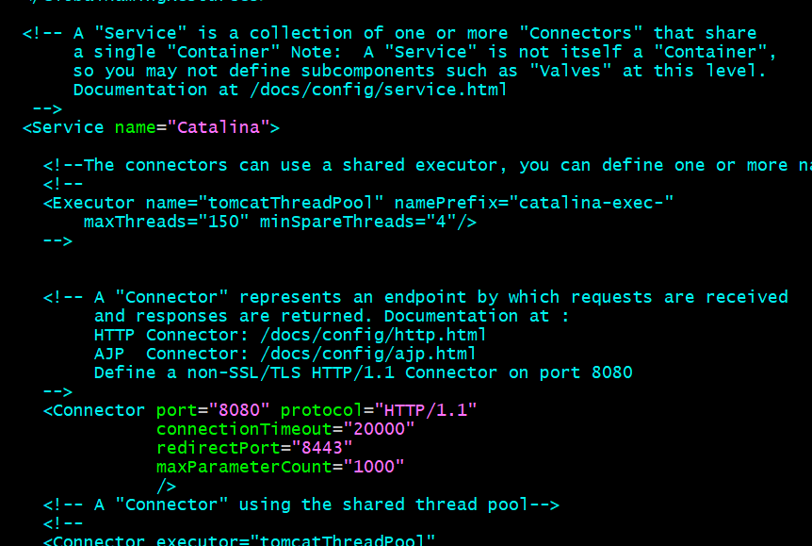
Change to
<Connector port="8082"
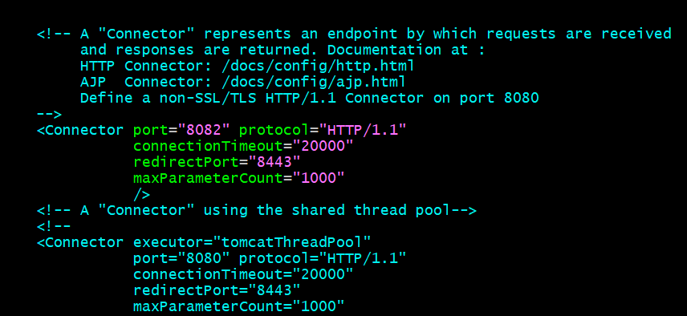Save.
Task 6: Deploy Sample Application on Web App
Create sample application
sudo mkdir /opt/tomcat/webapps/sample
Create
sudo vi /opt/tomcat/webapps/sample/index.html
Paste
<html>
<head>
<title>Tomcat</title>
</head>
<body>
<h1>Apache Tomcat Application</h1>
<h2>Running on Port 8082</h2>
</body>
</html>
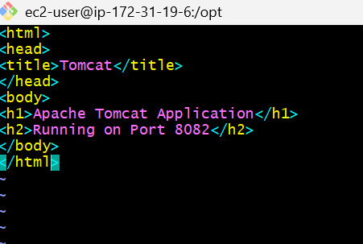

Task 7: Create tomcat.service for tomcat
sudo vi /etc/systemd/system/tomcat.service

Paste
[Unit]
Description=Apache Tomcat
After=network.target
[Service]
Type=forking
User=root
Group=root
Environment=CATALINA_PID=/opt/tomcat/temp/tomcat.pid
Environment=CATALINA_HOME=/opt/tomcat
Environment=CATALINA_BASE=/opt/tomcat
ExecStart=/opt/tomcat/bin/startup.sh
ExecStop=/opt/tomcat/bin/shutdown.sh
Restart=always
[Install]
WantedBy=multi-user.target
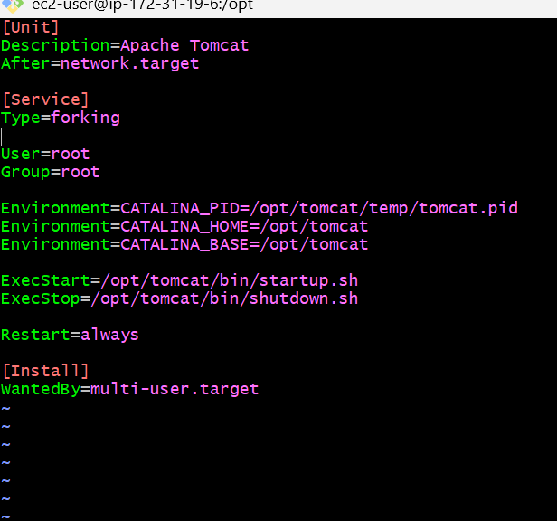

Enable service
sudo systemctl enable tomcat
Start
sudo systemctl start tomcat
Check
sudo systemctl status tomcat
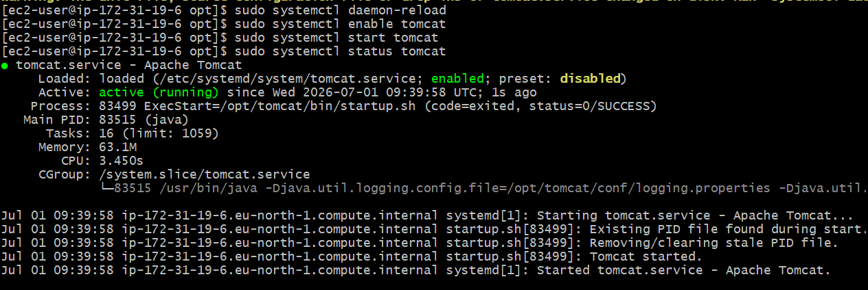
Test
http://Public-IP:8082/sample or
curl http://localhost:8082/sample
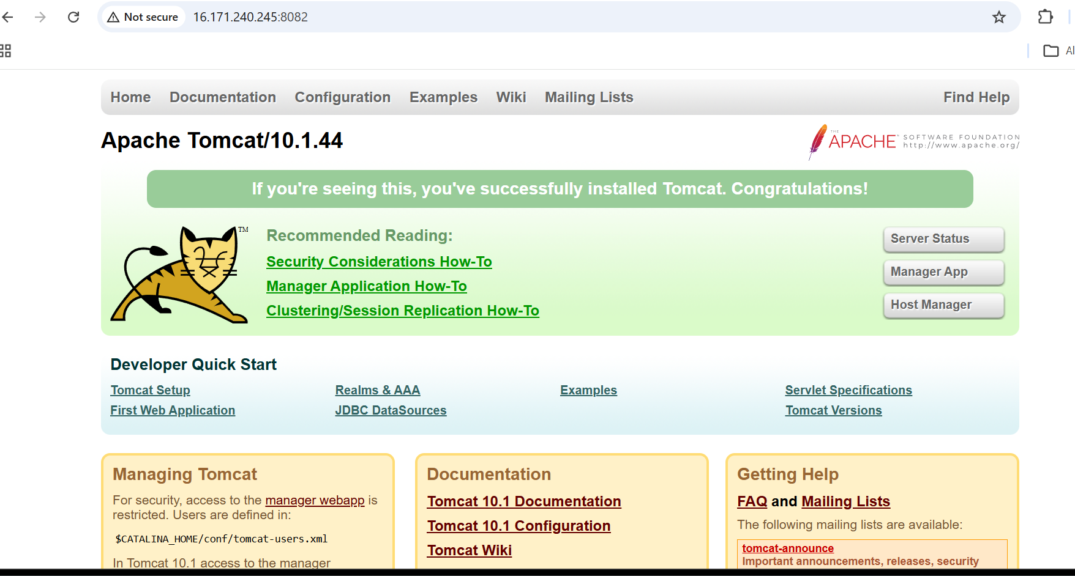
Task 8: Install HAProxy
Configure HA Proxy Server:
Launch 3 ec2 instances name as Server1, Server-2, HA-Proxy-Server.
Server-1 Steps:

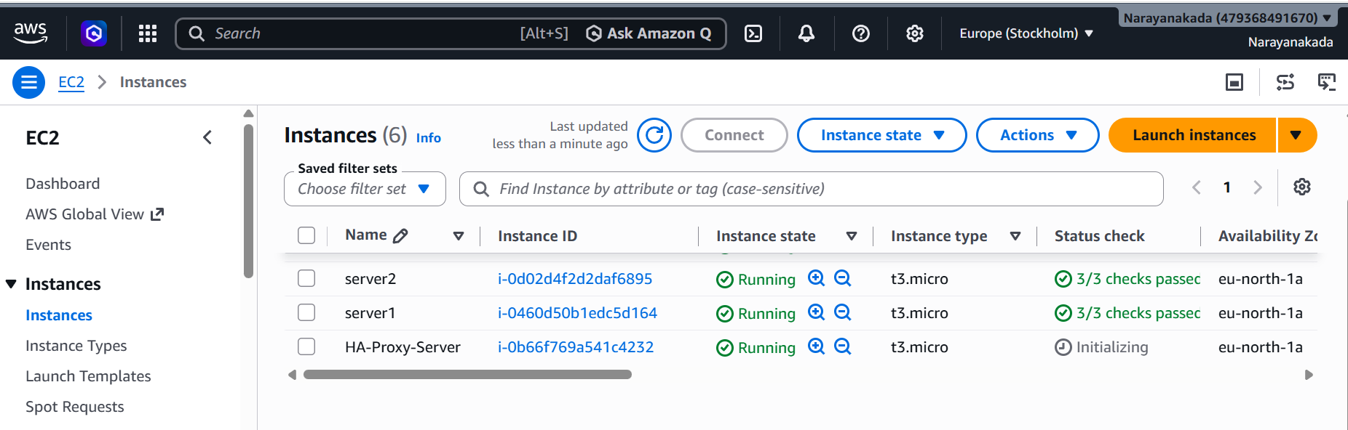
Run following command to Access the Server-1
- ssh -i your-key.pem ec2-user@Pubipaddress of Server-1 instance
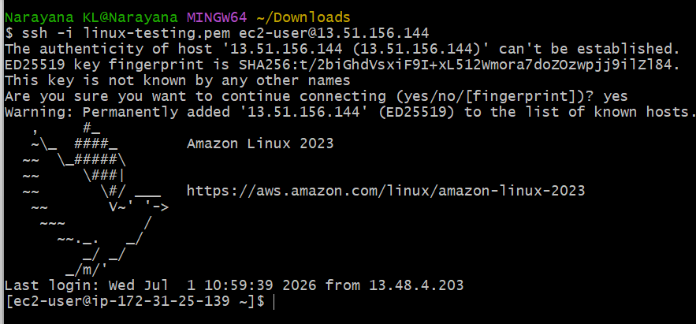

- sudo -i
- yum update -y
- yum install httpd -y
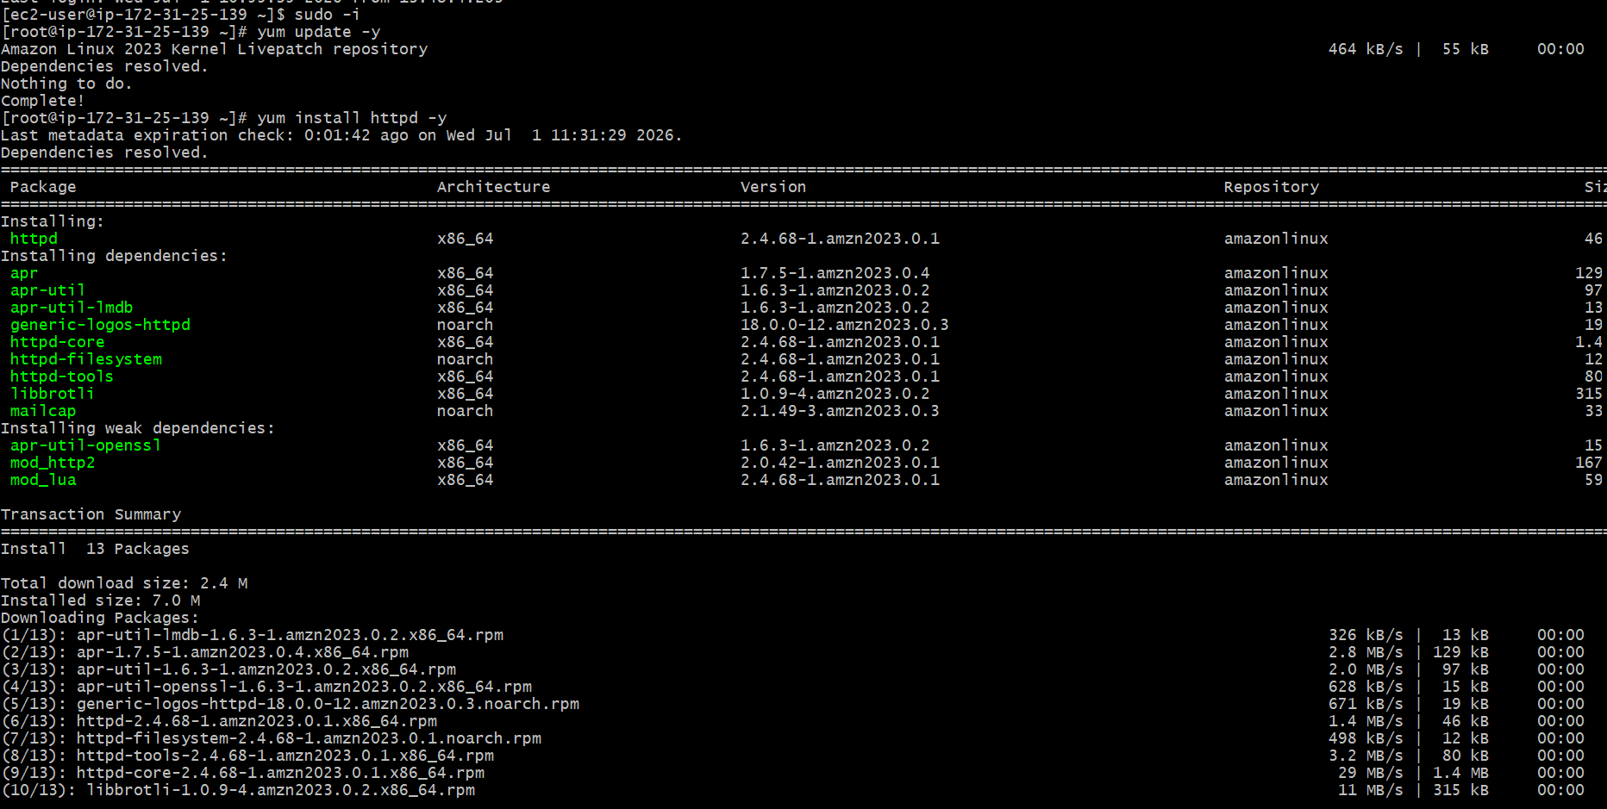
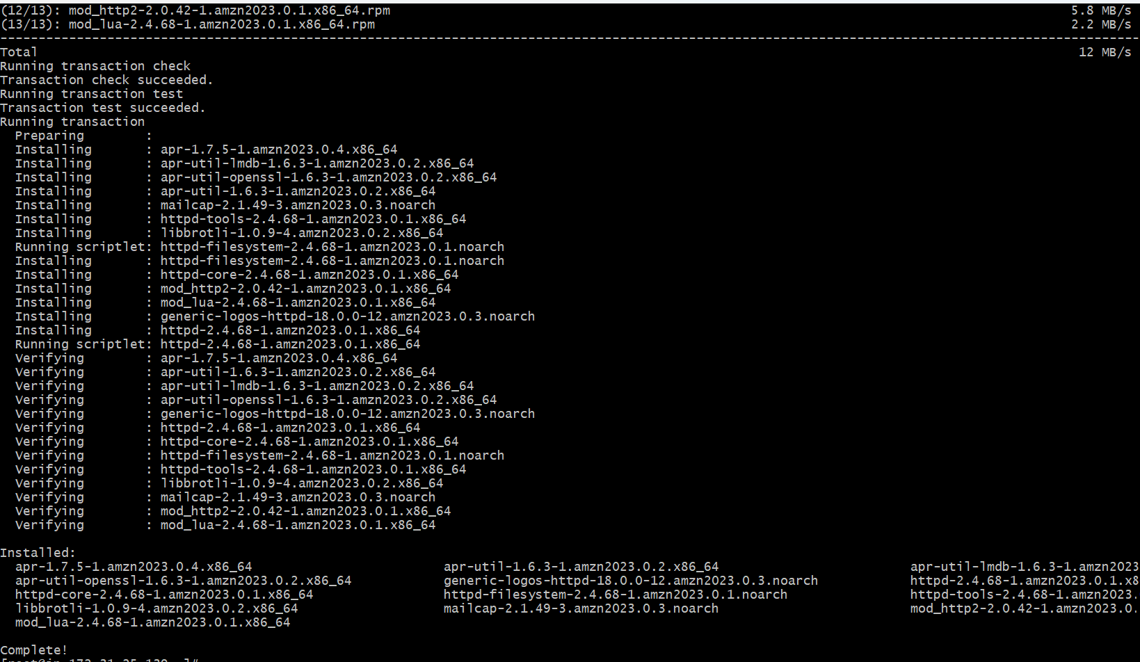
- Vi /etc/hosts
- Add HA-Proxy-Server Pubic IP Address
- Cat /etc/hosts
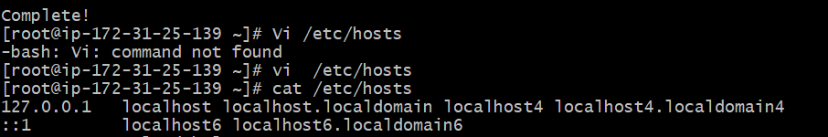
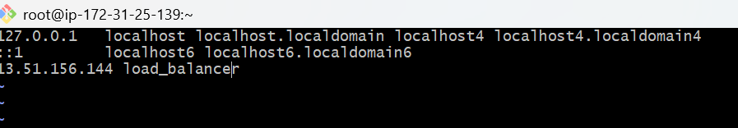

Run below command on Server-1
ping load_balancer -c 4
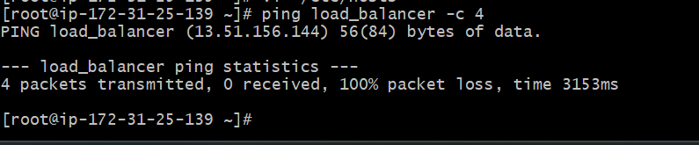
- systemctl start httpd
- systemctl status httpd
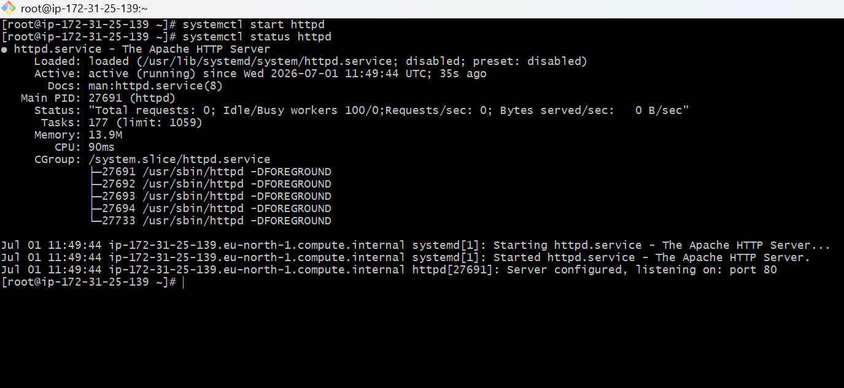
Browse with Server-1 Public IP address:80 it will work

Server-2 Steps:
Run following command to Access Server-2
- ssh -i your-key.pem ec2-user@Pubipaddress of Server-2 instance
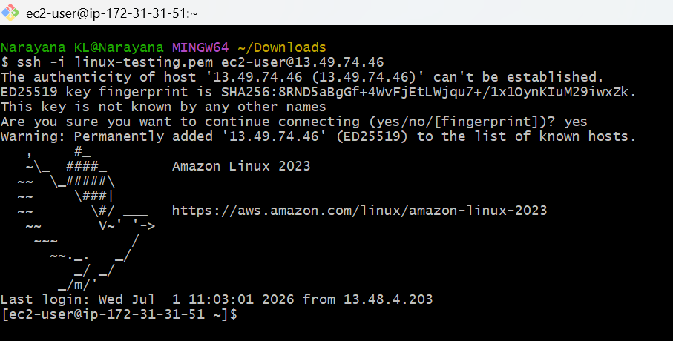
- sudo -i
- yum update -y
- yum install inginx -y
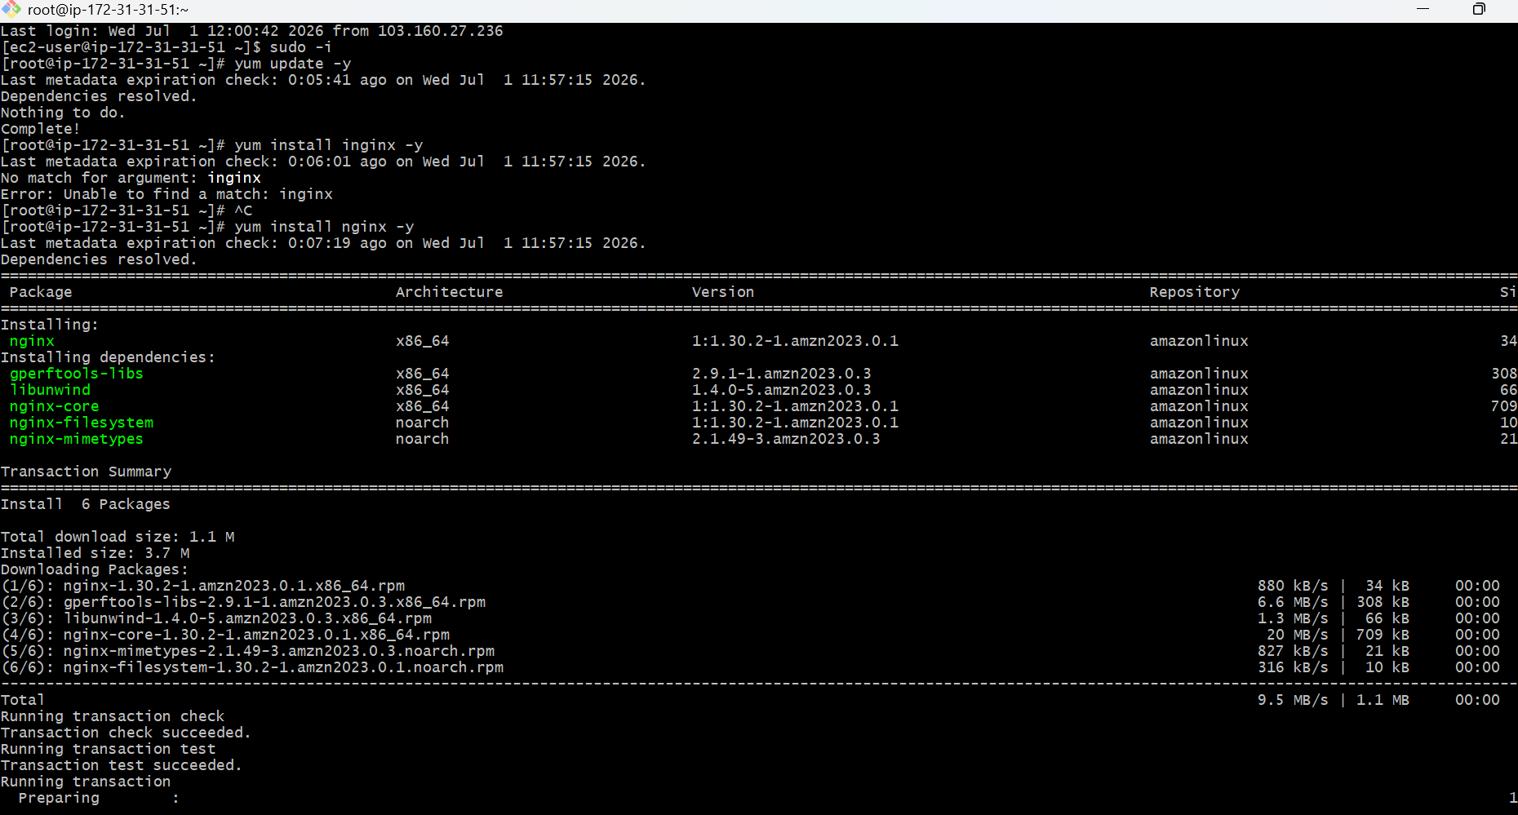
- vi /etc/hosts
- Add HA-Proxy-Server Pubic IP Address
- cat /etc/hosts
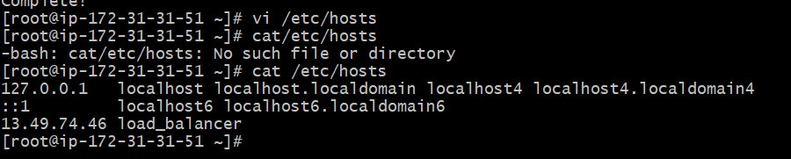
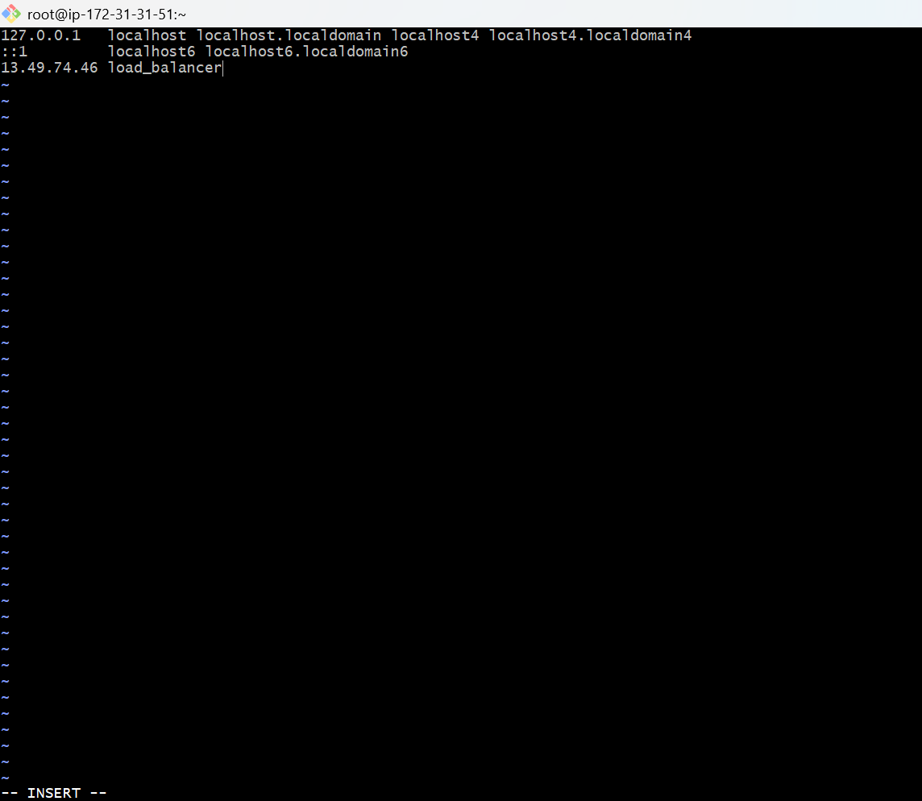

- Run below command on Server-2
- ping load_balancer -c 4
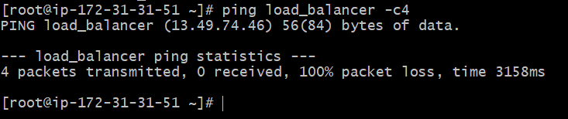

- systemctl start nginx
- systemctl status nginx
- Browse with Server-2 Public IP address:80 it will work

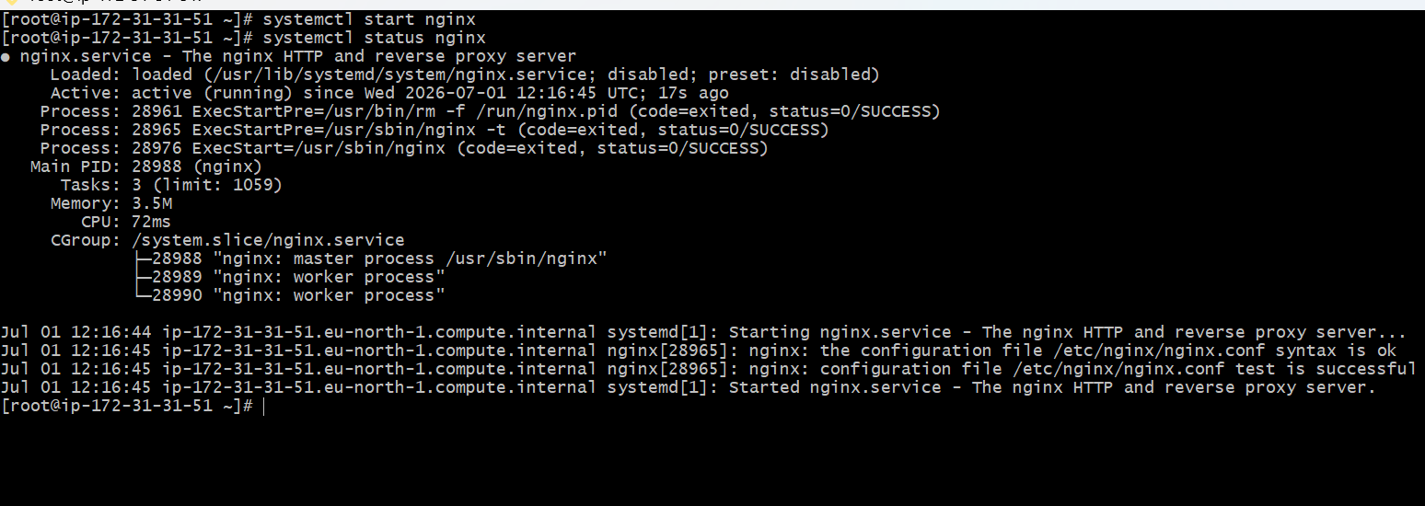
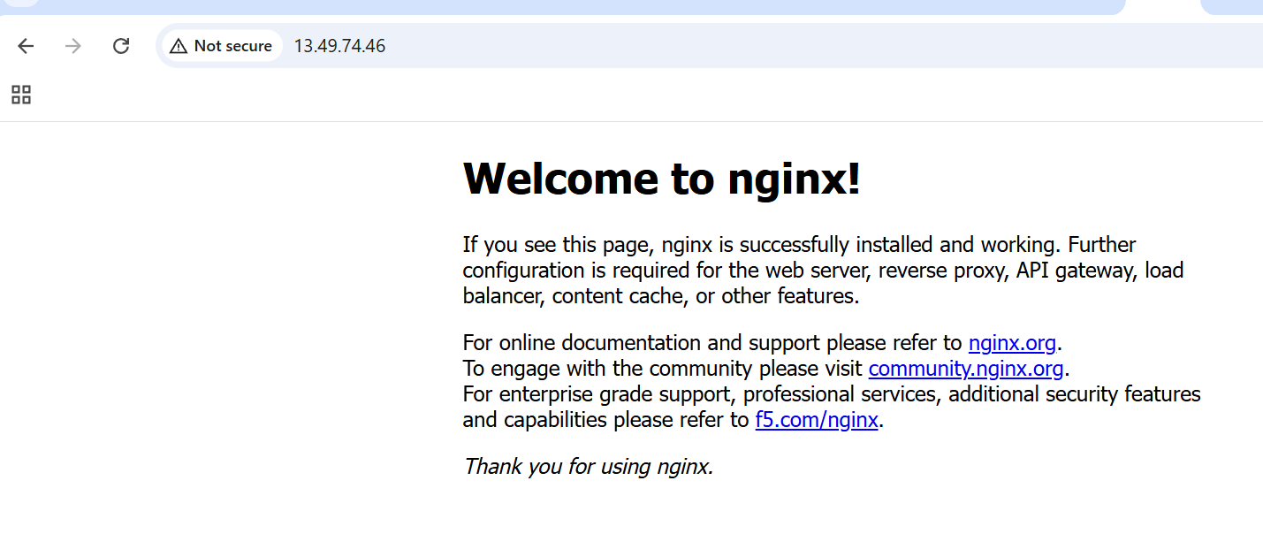
HA-Proxy-Server Steps:
Run following command to Access HA-Proy-Server
- ssh -i your-key.pem ec2-user@Pubipaddress of HA-Proxy-Server instance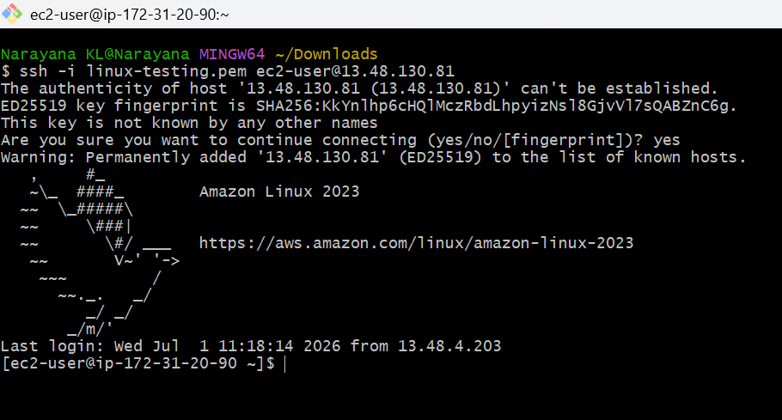

- sudo -i
- yum update -y
- yum install haproxy -y
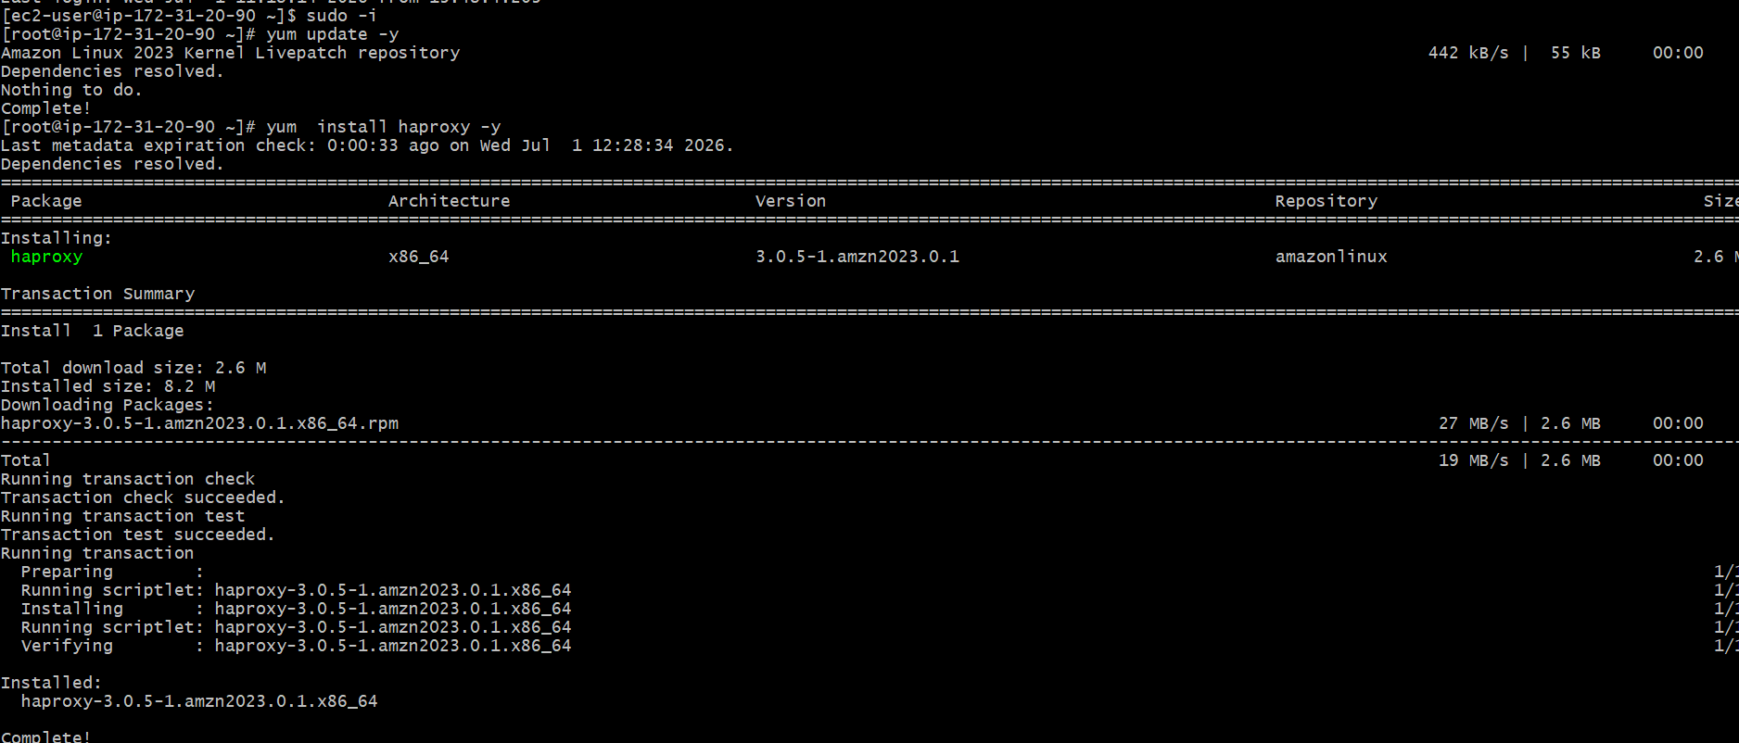
- vi /etc/hosts
- Add Server-1, Server-2 Public IP’s
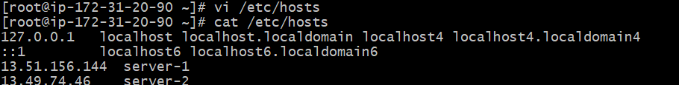
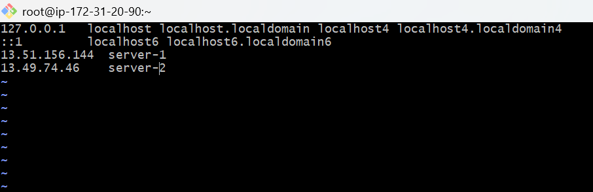
- vi /etc/haproxy/haproxy.cfg
- Add Server-1, Server-2 public IP’s
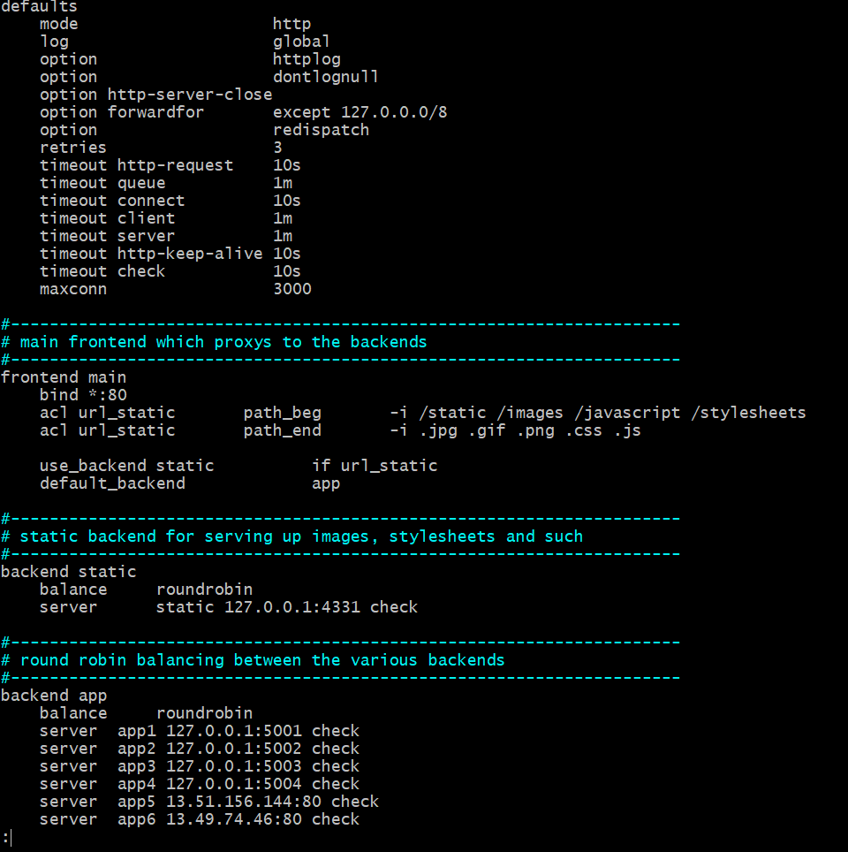
- systemctl enable haproxy
- systemctl start haproxy
- systemctl status haproxy
- now browse with HA-Proxy-Server PublicIP:80 it will distribute load to Server-1, Server-2

